Denver Lyric Opera Guild Internet and Smart TV Viewing Guide

As Denver Lyric Opera Guild continues to navigate the pandemic, we have been moved to take advantage of the many different concert and performance viewing options available on the Internet. As a result of DLOG presenting its first full live-streamed Competition for Colorado Singers, we have taken the first step of creating the DLOG YouTube channel. All Competition events starting in 2021 and for the future will be available on this channel. Simply navigating to this link with your phone or computer browser will allow viewing of all DLOG livestreams and archived videos. Note this link is also available from many pages of the DLOG Website. If you can get to DLOG’s site, you can always find a link to whatever DLOG events or archived videos are available.

While it’s fine to be able to watch these events on phones and laptops, Opera is always searching for grander venues. One such slightly grander venue available now is an Internet connected Smart TV. Many people have these, but do not realize they can watch YouTube and other streaming services from them. This guide will attempt to explain how.

To stream to a TV some options include:
- An Internet connected Smart TV with a YouTube app. (most smart tvs have this).
- A Roku or similar streaming device plugged into your TV.
- A phone or laptop coupled with a Google Chromecast plugged into your TV allowing you to cast what is playing on your phone or laptop to your TV.

Options 1 and 2 are very similar and outlined in this guide. Option 3 is handy if you prefer browsing on a phone or laptop and then playing to the TV rather than searching with a tv remote. A Chromecast is a $30 device and comes with directions if you wish to pursue this route.

Special thanks to Bill Warren of Calvary Baptist for the following instructions:

How to Stream from an Internet connected Smart TV or Roku streaming device

If you have a smart TV connected to the Internet, chances are very good that you can watch DLOG streams right on your sofa. There’s no cost and it’s pretty easy to do.

If you have an Xfinity or Dish Network voice remote, about the simplest thing you can try is to press the microphone button on your remote and say, “YouTube Denver Lyric Opera Guild” and it should take you directly to the DLOG YouTube channel. It is unclear if this will work for DirectTV and results may vary.

If you don’t have a voice remote, you can use your TV YouTube app alternative. The instructions here are for a Roku TV, but in principle, they should work for most any smart TV. When you first turn on your TV, you may see a list of choices similar to this. Some TVs are set up to automatically show a specific channel. In these cases, it may be necessary to press the Home button on your remote control.
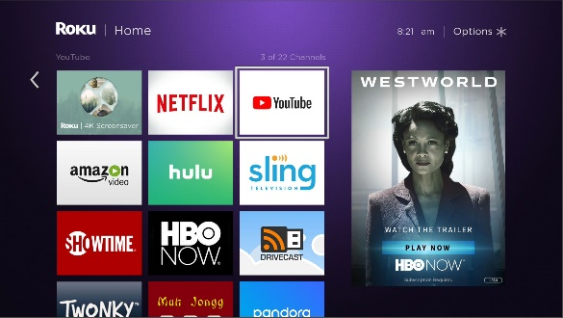
On the screen pictured here, you see a YouTube option as the third item on the top row. Use your remote control to move to the YouTube choice, then press the OK button on the remote control.

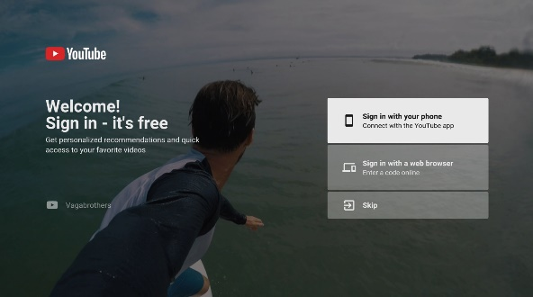
Your TV screen should change to show something like this—a YouTube sign-in screen. It is not necessary to have an account or to sign in to YouTube to see DLOG content. With your remote control, move the selection down to Skip and press the OK button.

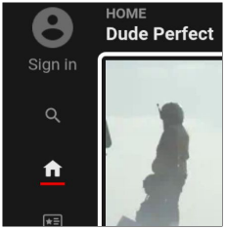
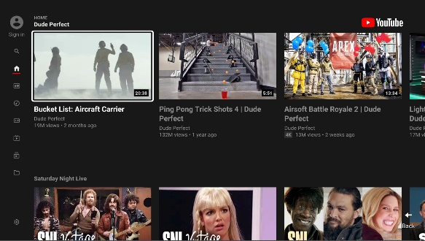
This will take you to the YouTube “Home” or main screen. Notice that there is a series of icons along the left side of your screen, including a small house-shaped icon. Use your remote control to move the highlight to this icon. As you do, you’ll see this list of icons open up to a list of menu options.

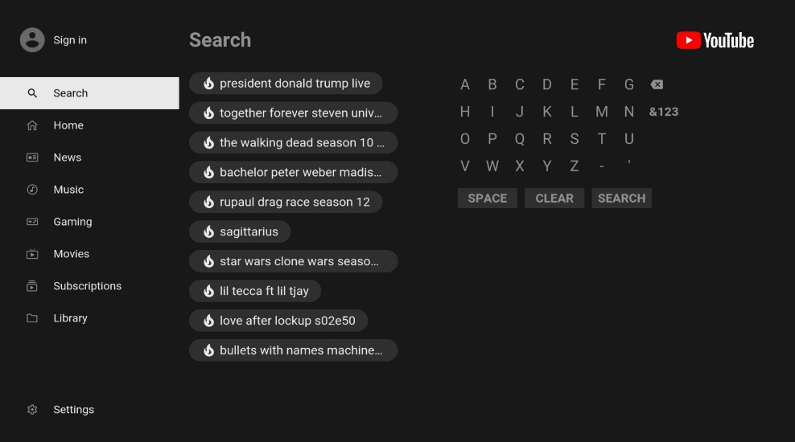
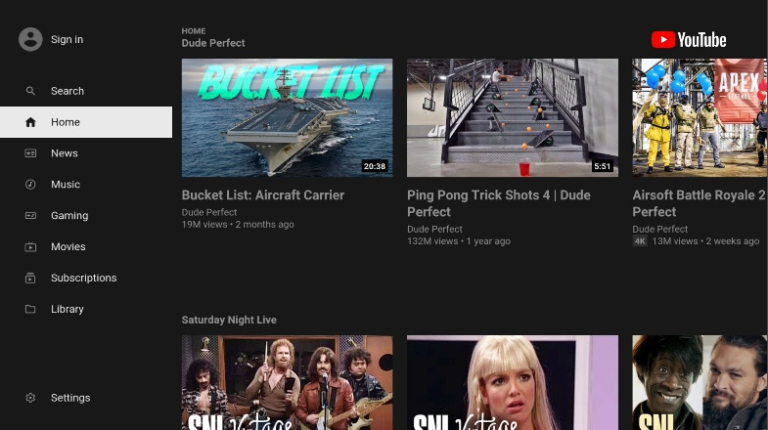
Once you have the full menu, move the highlight to Search and press the OK button. This will bring up the YouTube search screen.

You’re almost there!

Since there are millions of things to see on YouTube, you have to let YouTube know what you’re trying to find. And since your TV does not have a keyboard, you have to do this with your remote control. You’ll also see a list of suggested matches in the center of your screen. Use your remote to spell out “Denver Lyric Opera Guild” by selecting each letter on the list on the right, then pressing ok.

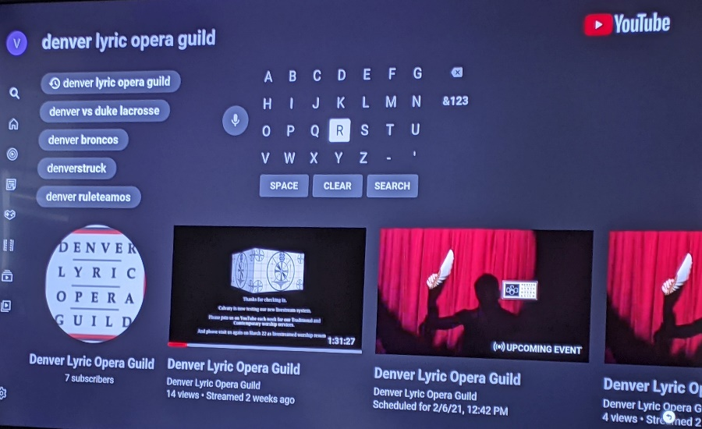
As you spell it out, you’ll see the list of suggested matches change with every letter you “type”. This is a little tedious, but you’ll get there. And next time, you’ll find that you don’t have to “type” it again.

Notice on this screen that YouTube has found the Denver Lyric Opera Guild channel and is displaying its logo image at the lower left. Move your highlight to this logo image and press OK.

At this point, you should see a screen that shows the DLOG YouTube channel with a top logo and whatever recent DLOG events that were live-streamed. If it is very close to a live-streaming event time, you should see a listing for the upcoming stream that says “Waiting to Begin.” If the event has already started, you’ll see the message “Live” here. If “Waiting to Begin”, just stand by until it says “Live”. Once it says “Live”, simply move the highlight to this event and press OK. The event should appear on your TV.

What if I have a Smart TV but I don’t know how to connect it to the Internet?

If you have Internet service at your home, there are two ways to connect most Smart TVs to the Internet—with an ethernet network cable, or with Wi-Fi.

Wired Connection

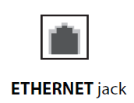
This is the most reliable way to connect your Smart TV to the Internet. If your Smart TV has a wired connector, it will have a jack on the back of the TV that looks like this. If you’re Smart TV doesn’t have this connection, skip down to the Wi-Fi Connection instructions.

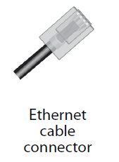
To connect it, you will need a network cable that looks like this on both ends. Note that it has eight wires and is not a regular telephone cable. Often these come with your Internet router and just get left in the box. Sometimes they even come with Smart TVs.

Of course, your Internet router will have to be close enough to your TV to make the connection. Simply plug one end of the cable into and open jack on the back of your router and the other end into the ethernet jack of the Smart TV.

Voilà—you’re done! Your Smart TV is connected to the Internet.

Wi-Fi Connection

This can be a little trickier to set up but should work in cases where your Internet router is too far from your Smart TV to reach, or where you do not have a cable.
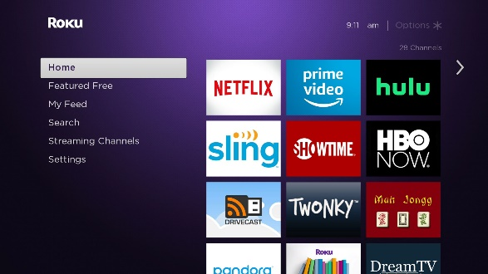
Press the Home button on your remote control. You should see the Roku Smart TV home men.

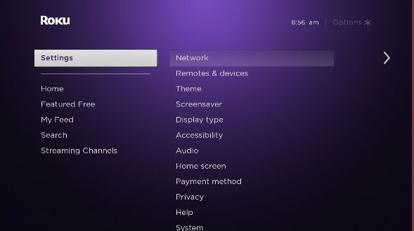
Move the highlight down to Settings. Press the OK button.

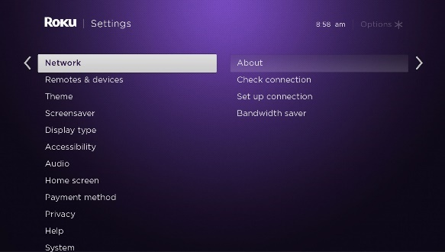
Move the highlight to Network and press OK.

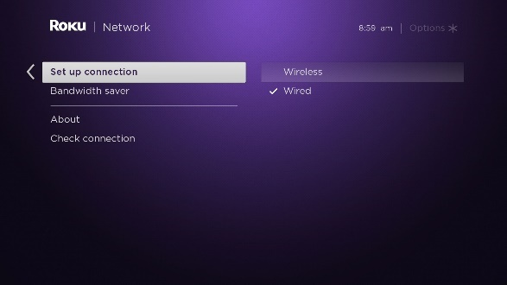
Move the highlight to Set up connection and press OK.

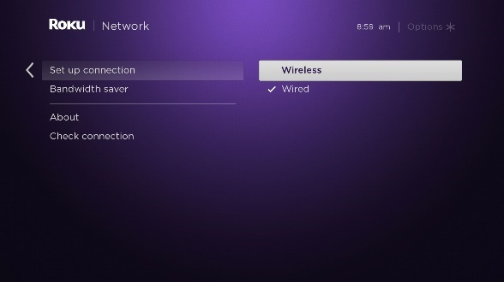
Move the highlight to Wireless and press OK.

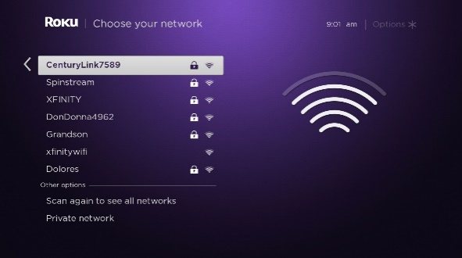
A list of nearby Wi-Fi networks will appear. Don’t be concerned if you see networks unfamiliar to you, as these may be neighbors or nearby businesses. Look for your network on the list. Move the highlight to it and press OK.

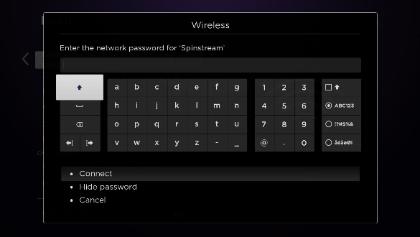
You will be asked to enter your wi-fi password. If you don’t know, look on your router, as sometimes it is printed on a label there.

Carefully enter your wi-fi password using your remote control’s arrows and selecting each letter with the OK button. Be careful to make sure that any capital letters are capitalized by using the shift key first (it’s the up-arrow on the picture here).

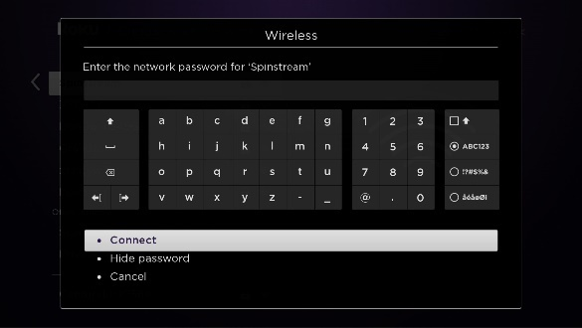
Once you’ve entered your wi-fi password, move the highlight down to Connect and press the OK button.

Once you’ve entered your wi-fi password correctly, you should see a message such as these confirming that you’re connected. Press Home, and start at the beginning of this document.
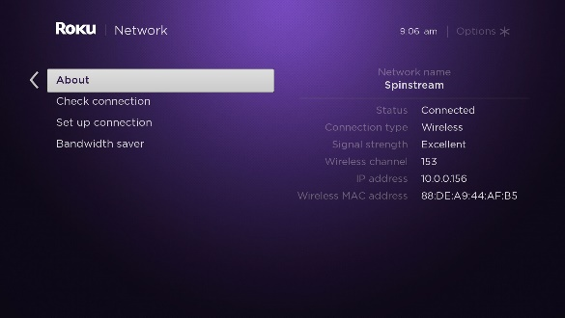
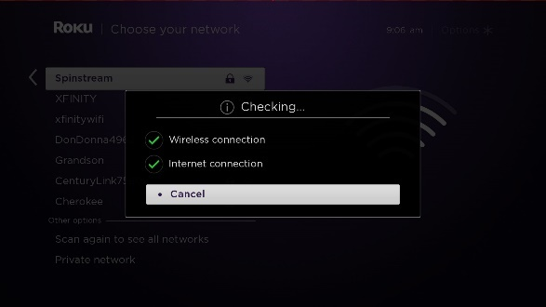

What if I press the Home button on my remote but there is no option for YouTube?

Often Smart TVs come with certain services already set up. (These are usually the ones they want you to buy subscriptions to, such as NetFlix…) Normally you can add additional channels for services that don’t automatically appear on the Home screen. Here’s how to add a service for YouTube on a Roku TV.

Press the Home button to get to the Home screen.

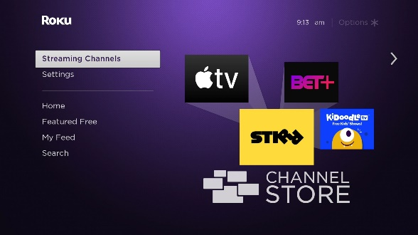
Move the highlight down to Streaming Channels and press the OK button.

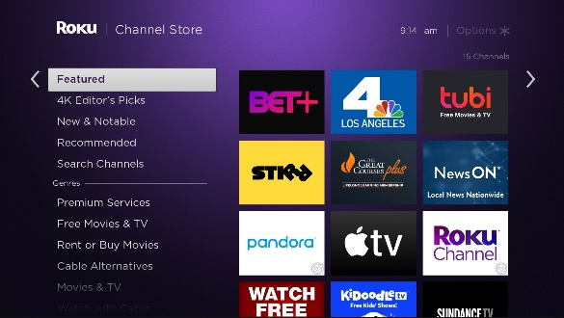
You can look through the list of featured services to see if YouTube is listed, but if may be quicker to search for the service. Move the highlight down to Search Channels and press OK.

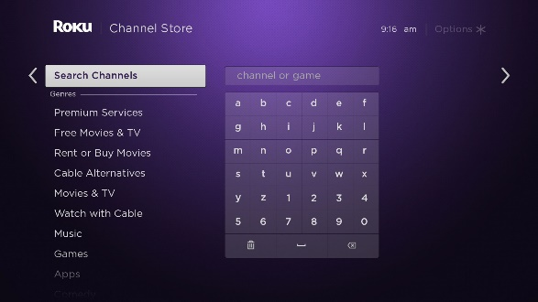
This will bring up a screen that allows you to tell Roku what service you are looking for. Move the highlight to the right into the typing area.

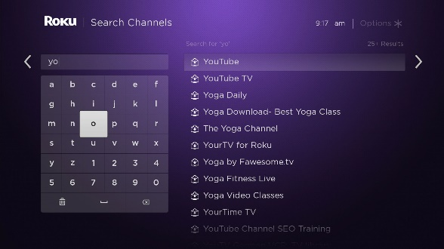
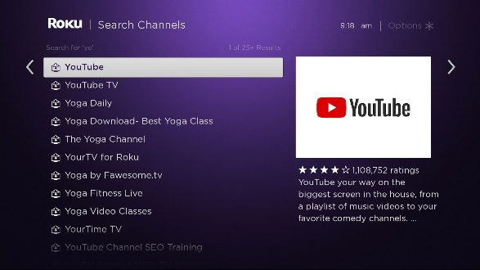
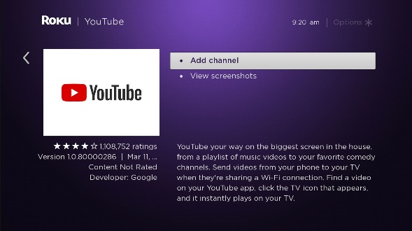
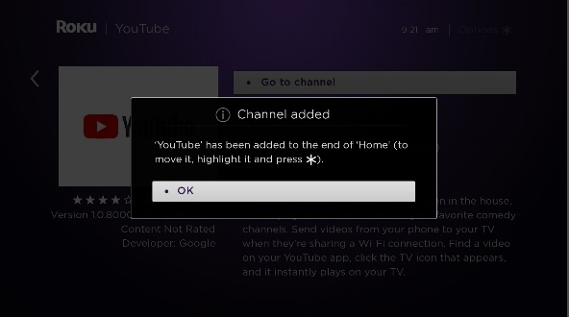
Enter the word “youtube” using your remote control’s arrows and selecting each letter with the OK button. Capital letters don’t matter here. You will probably only have to type 2-3 letters to have YouTube show up. Move the highlight to YouTube in the listing and press OK.

Roku will now give you a chance to confirm that you really want to add the YouTube service channel. With the highlight on YouTube on the list, press the OK button.

Press OK to confirm that you want to add this service.

You receive a message confirming the service channel has been added. Press OK. This should return you to the Home screen.

Please note that added service channels go to the bottom of the channel list on the home screen. You’ll have to use the arrows on your remote to move the highlight down to find the channel listing for YouTube when you’re ready to watch.

Note for Opera Enthusiasts:
If you follow the above instructions for installing the YouTube app on your TV, only changing your search to “met opera” instead of “YouTube”, you may be able to install the Met Opera streaming app (depending on device). This app provides a nightly free opera stream during COVID and, with subscription, allows the on-demand viewing of many years’ worth of Met performances. Also, most large opera houses worldwide provide similar streaming content. The following article provides a great jumping off point to find many of the best streams around: https://www.playbill.com/article/how-to-stream-opera-and-classical-music-performances

