
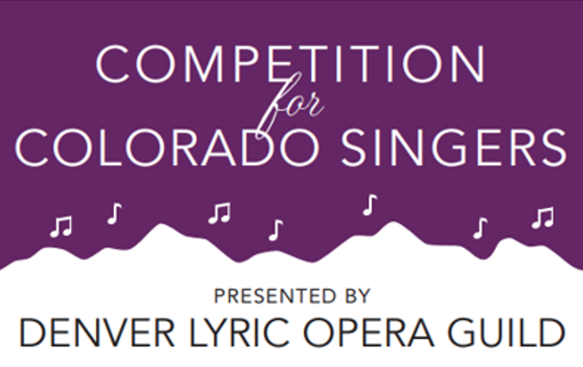
Competition Preliminaries
Saturday, March 7, 2026
9:00 AM – 5:00 PM

Competition Finals
Saturday, March 21, 2026
1:00 PM – 5:00 PM

Calvary Baptist Church / 6500 E. Girard Avenue / Denver, CO

Free and open to the public
DENVER LYRIC OPERA GUILD
Founded in 1965, Denver Lyric Opera Guild is a nonprofit membership organization committed to advancing the operatic arts by supporting the development of emerging vocal talent throughout Colorado. We invite you to learn more about our history, mission and the benefits of membership by exploring our website at www.denverlyricoperaguild.org. We welcome new members!

COMPETITION FOR COLORADO SINGERS
Launched in 1984, the annual Competition for Colorado Singers is the Guild’s signature event. It is designed to:
- Spotlight and support promising young operatic talent in Colorado.
- Provide substantial financial awards and professional exposure to help singers ages 23–32 pursue operatic careers.
- Offer mentorship and performance opportunities that can lead to engagements with major opera companies.
Since inception, the Competition has awarded over $1,000,000 in prize money and helped launch careers of singers who have gone on to perform with prestigious companies like the Metropolitan Opera, Santa Fe Opera, Opera Colorado, and San Francisco Opera.
GRANTS
The Guild provides grants to universities and opera apprentice programs across Colorado, totaling over $1,000,000.00 to date. Denver Lyric Opera Guild (DLOG) isn’t just a supporter of opera-it’s a lifeline for young vocalists and the institutions that train them. Through its grant program, DLOG plays a vital role in shaping the next generation of performers and enriching the cultural landscape across the state. DLOG grants provide scholarships and financial aid to aspiring opera artists, helping them afford tuition, coaching, and performance opportunities.


DENVER LYRIC OPERA GUILD
Supporting young Colorado Opera Singers for over 60 years
Because every great aria begins with a first note

Appointed Positions

Phyllis Wicklund
Parliamentarian
Linda Young
Photographer
Ian T. Caiozzi
Communications Chair

Committees
Finance
Education
Public Relations
Communications
Nominating
Special Events
Summer Party
Proofreaders

2025-2026 DLOG Officers

Gayle Landis
President
Karen Bruggenthies
Immediate Past President
Norelee Bush
President Elect
Karen Bruggenthies
Competition Vice President
Lisa Curtis
Development Vice President
Rebecca McAlister
Education Vice President
Kevin O’Connor
Finance Vice President
Deb Roth
Membership Vice President
Linda Bjelland
Recording Secretary

Dr. Jeremy Reger | International Performer and Educator
Jeremy Reger maintains an active performing, teaching, and musical coaching career. Currently serving as the Head of Music at Central City Opera, he has also served on the music staff at Virginia Opera, Opera Steamboat, Eugene Opera, Hawaii Opera Theater, Mill City Opera, Central City Opera, St. Paul Chamber Orchestra, and the Minnesota Opera. He has song recordings with mezzo-soprano Michelle DeYoung and baritone Andrew Garland. As an orchestral pianist, he has performed with the Virginia Symphony, Colorado Symphony, Boulder Philharmonic, Williamsburg Symphony, Carmel Symphony, Terre Haute Symphony, and Aspen Festival Orchestra.
At the University of Colorado Boulder, Reger teaches classes in vocal repertoire, diction, audition techniques, and performance, and maintains a coaching studio. Prior to CU Boulder, Reger taught at the Music Academy of the West, Christopher Newport University and at Indiana University's Jacob’s School of Music. A strong advocate of new opera Reger has participated in workshops for composers Damien Geter, Jake Heggie, Tom Cipullo, Ricky Ian Gordon, Kevin Putz and Mark Adamo.

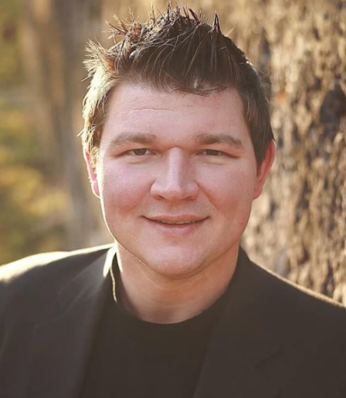

Competition Accompanist



CATHERINE PRACHT
Soprano Catherine Pracht has established herself as a leading opera singing actress performing with such prestigious companies as Virginia Opera, Central City Opera, Chicago Opera Theater, and Opera Philadelphia. Pracht’s repertoire spans from baroque to modern American opera, with a focus on new works. She has performed in over thirty operas composed after 1945, including the 2023 premiere of Laura Kaminsky’s and Lida Moore’s February. Other notable contemporary operas include Puts’ Elizabeth Cree, Heggie’s Three Decembers, and Spears’ Fellow Travelers. She recently starred in Central City Opera’s production of The Knock. In 2023 Ms. Pracht joined the faculty of Bowling Green University as an Assistant Professor of Voice.

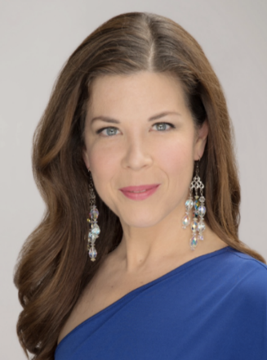

CYNTHIA LAWRENCE
Recently inducted into the Colorado Music Hall of Fame, soprano Cythia Lawrence has been a principal artist at The Metropolitan Opera; Washington National Opera; Guangzhou Opera House; Royal Albert Hall, London; Lyric Opera of Chicago; Opera Colorado; Lithuanian National Opera; Royal Opera House, Covent Garden; Paris Opera, and many more. Opera roles include Madama Butterfly; Amelia in Un Ballo in Maschera; Roxanne in Cyrano de Bergerac; Tosca; Rosalinda, Die Fledermaus; Maddelena in Andrea Chenier; Lavinia, Mimi and Musetta, La Boheme; Micaela and Carmen, Carmen; The First Lady and Pamina, Die Zauberflöte; Fiordiligi, Cosi fan Tutte; Lady Macbeth, Verdi’s Macbeth; Dolly, Sly; Liú, Turandot; and Marguerite, Faust. She performed over 70 times with Luciano Pavarotti. A DVD “A Tribute to Pavarotti: One Amazing Weekend in Petra” features her performances and tribute to Pavarotti. She appeared in concert in Kuala Lumpur, Malaysia, Lima, Peru, and Martingy, Switzerland. Ms. Lawrence is a professor of Music Performance Voice at the University of Kentucky.

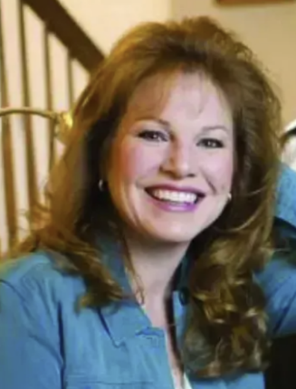
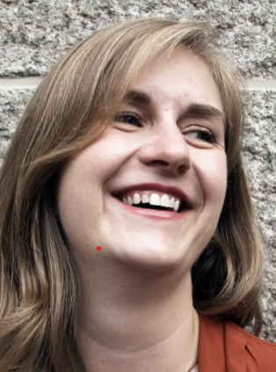
CORINNE HAYES
Corinne Hayes is a stage director, dramaturg, and educator, and was named Head of Training Programs at Central City Opera. In the 25-26 season, Corinne will make directorial debuts with Washington National Opera (Revival Director, The Little Prince) and Opera Lafayette (repertoire TBA), while continuing her tenure as Director of Acting for the Maryland Opera Studio. This summer, she serves as Head of Training Programs at Central City Opera. In the 23-24 season, Corinne led new productions of Mozart’s Die Zauberflöte (Annapolis Opera) and FIorencia en el Amazonas (Maryland Opera Studio). Highlights of the 22-23 season included and a new production of Don Giovanni with the Maryland Opera Studio. In addition to her role at the university, Corinne serves as Artistic Advisor for DC-based opera theater company IN Series. Corinne’s long association with Washington National Opera includes serving as Assistant Director to Francesca Zambello (Candide, The Little Prince, et al.) and E. Loren Meeker (Don Giovanni).

Judges - Preliminary Competition

JENNIFER ROWLEY
Soprano Jennifer Rowley is acclaimed worldwide for her unforgettable voice and remarkable stage presence, singing a richly varied repertoire that includes many of opera’s greatest heroines. Her 2025/26 season brings three role debuts: the fierce Lady Macbeth in Verdi’s Macbeth at the Teatro Carlo Felice, Genova, Turandot with Florida Grand Opera, and Maddalena di Coigny in Giordano’s Andrea Chenier at the Metropolitan Opera. She will begin the 2025/26 season at the Kennedy Center, singing the title role in Verdi’s Aida with Washington National Opera. Ms. Rowley will then perform Madama Butterfly with the Dallas Symphony, both in Dallas and at Bravo! Vail. As the founder and director of Aria Bootcamp Ms. Rowley holds an annual artist residency at her alma mater, Baldwin Wallace University Conservatory of Music, and is currently on the voice faculty at the Curtis Institute of Music. Audiences will remember Jennifer Rowley’s triumphant Metropolitan Opera role debut as Roxane in Alfano’s Cyrano de Bergerac (2017) which inspired universal critical praise. The New York Times raved that this was a “break-through moment,” further adding that for the heartbreaking final scene, “Ms. Rowley sang with an intensity of expression and a subtly embittered sound that suggested a singer for enormous gift and promise.”



TROY COOK
American baritone Troy Cook made notable debuts in past seasons as Ford in Hamburgische Staatsoper’s Falstaff, following his debut with the company as Marcello in La bohème, and with the Royal Opera, Covent Garden as Guglielmo in Così fan tutte. 2025-2026 season engagements include Marcello in La bohème with Austin Opera, Handel’s Messiah with the Pittsburgh Symphony, and a return to The Metropolitan Opera, covering Gerhard in the company’s season-opening premiere of The Adventures of Kavalier and Clay. He performed as baritone soloist for Carmina Burana with the Grant Park Festival, Oregon Symphony Orchestra, and the Vermont Symphony Orchestra. Troy’s 2024-2025 season began with his home company, Opera Philadelphia, singing the role of Paul Devon in the North American premiere of The Listeners. A champion of new music, he bowed in Virginia Opera’s world premiere, Loving v. Virginia (Geter/Murphy Moo), portraying ACLU attorney Bernard Cohen. Cook joined Spoleto Festival USA reprising the role of Athanael in a newly produced concert version of Thaïs. Also during the season, Cook revived his hugely popular Major-General Stanley in The Pirates of Penzance for Knoxville Opera, and Giorgio Germont in Buffalo Philharmonic Orchestra’s performances of La traviata (conducted by JoAnn Falletta).

CHRISTOPHER KOELZER
Solo and collaborative pianist Dr. Christopher Koelzer hails from the San Francisco Bay Area, and performs, records, music directs, and coaches regularly in the New York City, Washington, D.C., and the San Francisco Bay areas. Christopher began collaborating in opera, musical theater, and chamber music at age 13, working with Mission City Opera in Santa Clara, CA, and Lyric Theater of San Jose, CA. Christopher currently teaches and performs as Music Faculty and Lecturer at San Francisco Conservatory of Music, Stanford University, and San José State University. Christopher has been invited to perform across the world as a solo and collaborative pianist. He received an Oscarson Grant to attend the International Music Academy at Plzen, Czech Republic in 2009. He attended Aspen Music Festival and School with full scholarship from 2011-2012, returning as Vocal Fellow in 2014. He was awarded Outstanding Collaborative Pianist Award and Grand Prize Art Song in the Metropolitan International Music Festival Competition in New York, 2016 with mezzo-soprano Nicole Lévèsque. D.C., a performance that collaborated with Hong Kong Ballet and Terra Firma Dance Company. Christopher joined the Merola Opera Program for its 2019 season as Apprentice Coach, premiering Jake Heggie’s If I Were You.


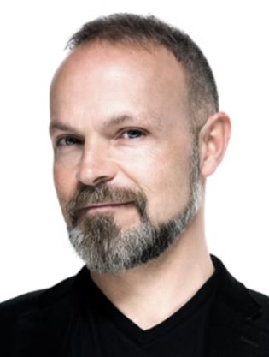

Judges - Final Competition

2026 Competition Awards
First Place: $10,000 GALEN & ADA BELLE SPENCER FOUNDATION AWARD
Recipient

Second Place: $5000 LISA CURTIS & KATHY AND PETER VAN ARSDALE AWARD
Recipient

Third Place: $4500 GERI SHELDON AWARD
Recipient

Fourth Place: $4000 GAYLE LANDIS IN MEMORY OF GARY LANDIS AWARD
Recipient

Fifth Place: $3500 TOM AND MARY CONROY AWARD
Recipient

Sixth Place: $3000 CAROLE JOHNSON AWARD
Recipient

Seventh Place: $2500 MARCIA RAGONETTI AWARD

Recipient

4 Certificates of Merit $1000 Each

LISA CURTIS IN HONOR OF BECKY GANTNER LINDA YOUNG IN MEMORY OF EUGENE YOUNG
Recipient ___________________________ Recipient _____________________________
JULIE JOHNSTON IN MEMORY OF HARRY WILLIAMS AWARD KAREN & ANDREW RITZ IN HONOR OF KAREN BRUGGENTHIES
Recipient ___________________________ Recipient ______________________________

JACKIE WRITZ IN HONOR OF CHECK-IN VOLUNTEERS

Recipient _____________________________

5 Honorable Mentions $500 Each – SPONSORED BY SUZANNE BUFTON IN MEMORY OF RICHARD BUFTON,
JOHN & GERDA TURNER, KAREN SALIMAN, AND LINDA BJELLAND
Recipients
__________________________________________________________________________________________________

Marcia Ragonetti Exceptional Mezzo Award $500
Recipient

Fourth Place: $4000 Gary & Gayle Landis Award -
Alice Del Simone – Soprano
Alice Del Simone enjoys performing varied repertoire including performances as Kitty Hart in Jake Heggie’s Dead Man Walking with Eklund Opera and Sophie in Richard Strauss’ Der Rosenkavalier with Boulder Opera. Recent operatic appearances include Bubikopf in Viktor Ullman’s Der Kaiser von Atlantis with Colorado MahlerFest and Vera Tyrrell in Mark Adamo’s Sarah in the Theater with CU NOW. On the concert stage, Del Simone has recently performed the Israelitish Woman in Handel’s Judas Maccabaeus with Seicento Baroque Ensemble and as soprano soloist in Handel’s Messiah with Boulder Bach Festival and Kalos Arts Foundation. In 2025, Del Simone was the first-place winner of the Art Song Colorado Competition. She is also an active choral performer. She has recently performed with Colorado Bach Ensemble, Boulder’s Ars Nova, 21V, Volti, and San Francisco Ballet, Left Coast Chamber Ensemble, Berkeley Symphony, and ODC among others. She is currently pursuing a DMA in Voice Performance & Pedagogy.

Third Place: $4500 Myrle F. Hoffman Memorial Award -
Alex Granito – Baritone

Alex Granito is a baritone from Orange County, CA. He is currently a Florida Grand Opera Studio Artist. This year Alex is an AGMA contracted cover for the roles of Audebert in Silent Night and Dr. Falke in Die Fledermaus. He will also be performing the role of The Mandarin in Florida Grand Opera’s production of Die Fledermaus. During the 2024-2025 Season, Alex was an Artist in Residence at Opera Colorado where he performed the roles of Schaunard in La Boheme and Corporal in Daughter of the Regiment on the Ellie Caulkin’s Opera House mainstage. He participated as a Studio Artist at Chautauqua Opera where he performed the role of Young Man in the world premiere of Love, Loss and a Century Upon Us.

Second Place: $5000 Kenneth King Foundation Award -
Hallie Schmidt – Soprano

American soprano Hallie Schmidt began her 2025-2026 season with a return to Pacific Northwest Opera as Armida in Handel’s Rinaldo. She will then reprise her favorite role of Zerbinetta in Ariadne auf Naxos the following spring also at PNO. During the summer of 2025, Hallie was an Apprentice Artist at Des Moines Metro Opera, where she performed in The Flying Dutchman, The Cunning Little Vixen, and The Rake’s Progress. An avid lover of producing, Hallie also directed and led Olympia Opera Theatre’s first festival in August of 2025, where she is the Artistic Director and Co-Founder. Hallie was engaged for the 2024-2025 season as an Artist in Residence at Opera Colorado. There she covered Marie in The Daughter of the Regiment, as well as sang the student matinee, followed by Musetta (study cover) in La Bohème, and Inez in the spring concert production of Il Trovatore. In April 2026, Hallie will be performing the role of Zerbinetta in Strauss’ Ariadne auf Naxos.

First Place: $10,000 Galen & Ada Belle Spencer Foundation Award

Claudia Diaz - Soprano

Puerto Rican soprano Claudia de Lourdes Díaz, originally from San Juan, but raised in the city of Caguas, graduated in 2020 from the Conservatory of Music of Puerto Rico with honors and a bachelor’s degree in Vocal Performance. She is currently earning a Performance Certificate at the Lamont School of Music under the tutelage of renowned soprano Heidi Melton. She was selected for the Vozarteum Opera Festival in 2019; traveling from San Diego, California to Baja California, Mexico, performing in various venues with a range of diverse repertoire. Afterward, Ms. Díaz was accepted to Houston’s Grand Opera, Young Artists Vocal Academy and over the course of the 2021 summer, she acquired a scholarship and placement in the Bologna International Opera Academy. Claudia was a 2025 winner of the Colorado – Wyoming District Metropolitan Opera Laffont Competition. She recently made her debut with the Colorado Symphony performing in Contreras’ Corridos. Claudia is currently pursuing an Artist Diploma at San Francisco Conservatory of Music where she is on a full scholarship.

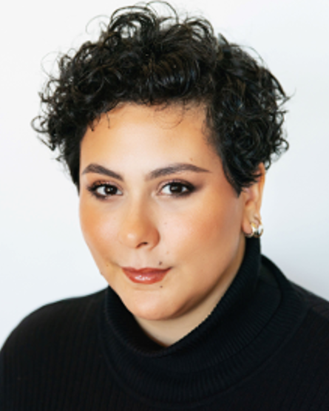

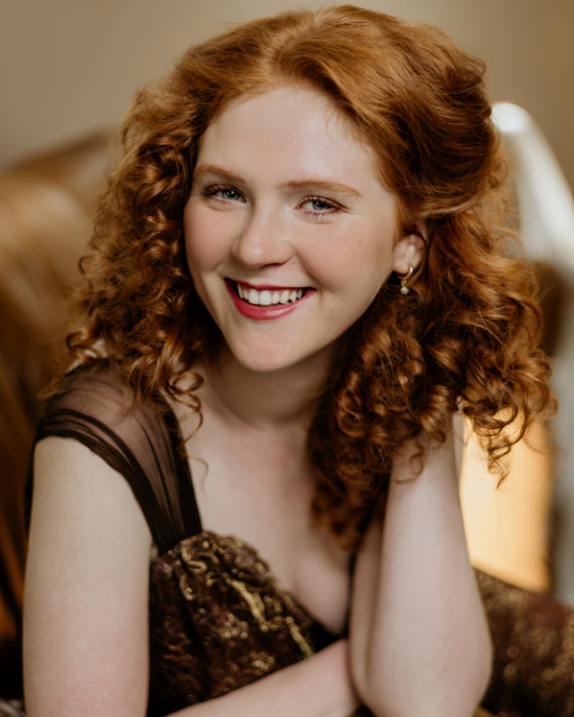
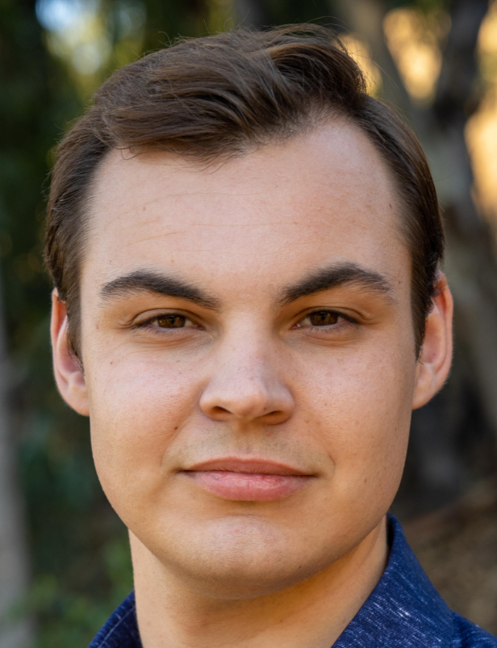
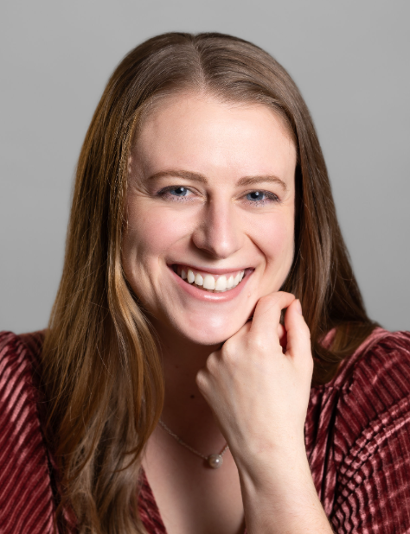

2025 COMPETITION AWARD WINNERS

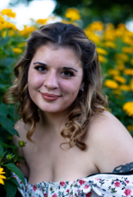
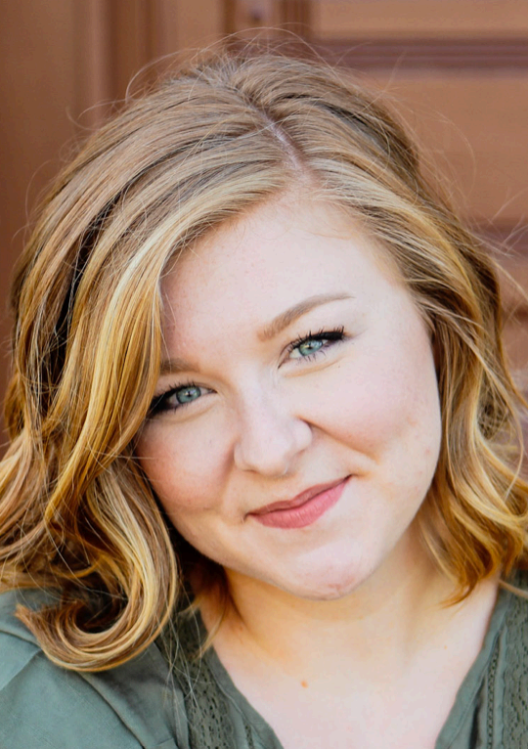
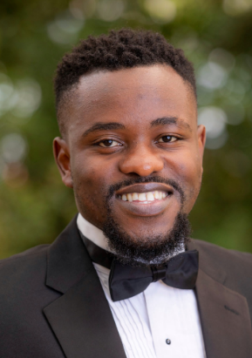
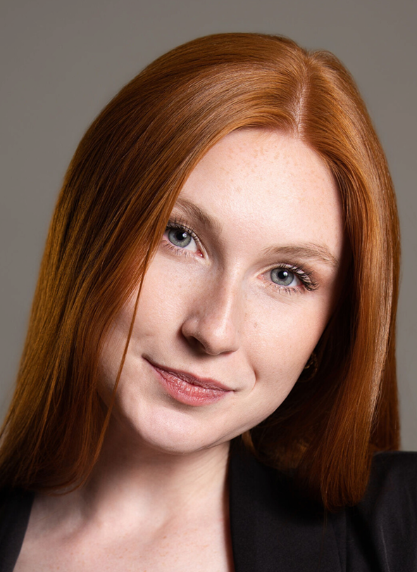

Seventh Place: $2500 Marcia Ragonetti Bel Canto Fund Award -

Sidney Grimm – Soprano

Sidney Grimm received her Bachelor of Arts in Music and Bachelor of Science in Psychology from Central Washington University. She was awarded Central Washington University's College of Arts and Humanities Award for Achievement in Arts or Performance. She is currently working on her Master of Music in Vocal Performance at the University of Colorado Boulder. Roles include Gretel from Engelbert Humperdinck's "Hänsel und Gretel," Littler Daughter from Missy Mazzoli's "Proving Up," and Cupid from Jacques Offenbach's "Orpheus in the Underworld".

Sixth Place: $3000 Carole Johnson Award -

Andrew Konopak – Baritone

Andrew Konopak is working toward his M.M. in vocal performance and pedagogy at the University of Colorado-Boulder, studying with Professor Andrew Garland. He worked professionally around Southern California for seven years where he became known for his “rich clarion baritone” (San Diego Story), singing with both San Diego Opera and Los Angeles Opera Chorus, and performing in concerts around the area. He has worked as a baritone soloist with the San Diego Master Chorale, La Jolla Symphony, San Diego Festival Chorus, and Artes Vocales of Los Angeles. With San Diego Opera, Konopak performed Il Commissario in Madama Butterfly, Grégorio in Romeo et Juliette.. Since coming to Colorado, Andrew has sung bass solos in both Handel’s Messiah and Bach’s B minor Mass with Longmont symphony, Pirate King in Gilbert & Sullivan’s “Pirates of Penzance,” and earlier this year had the honor of singing in a masterclass with Renée Fleming. Andrew recently performed the role of Joseph De Rocher in Heggie’s Dead Man Walking.

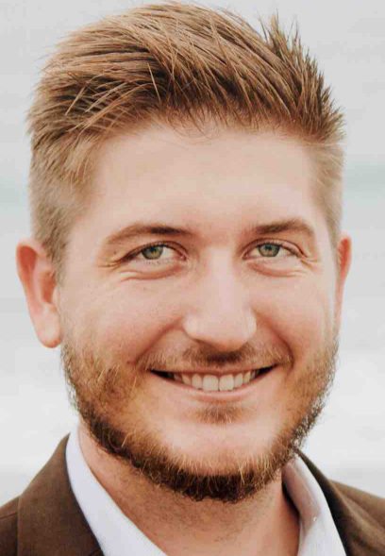

Fifth Place: $3500 Tom & Mary Conroy Award

Hanyue Zhang – Soprano

Hanyue Zhang began her musical journey at the age of eight, starting with piano lessons and joining the school children’s choir. At fifteen she pursued formal training in classical voice performance. In 2018 she was accepted into the Tianjon Conservatory of Music, where she majored in voice performance and dedicated herself to the study of opera and Bel Canto. Her passion for vocal arts led her to continue her studies at the Lamont School of Music at the University of Denver, where she received her Master of Music degree in Vocal Performance. She is currently working towards her Artist Diploma at the Cleveland Conservatory of Music.

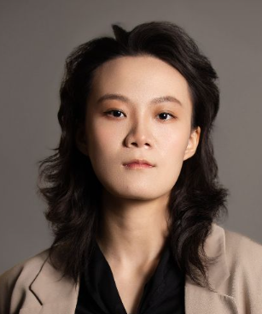

CERTIFICATE OF MERIT WINNERS

Mykayla Fitzpatrick Mackenzie Laun Sibongakonkhe Misibi

FIRST PLACE PAST COMPETITION WINNERS
2021
Anna Montgomery

2022
Lauren Baumgarner

2023
Griffen Hogan Tracy

2024
Miguel Angel Ortega Banales

2025
Claudia Diaz

2009
Juli Bunyak

2010
Christie Hageman

2011
John Lindsay

2012
Kimberly Render

2013
Thomas Kittle

2014
Rebecca Kidnie

2015
Taylor Raven

2016
Sarah Cambidge

2017
Ekaterina Kotcherguina
2018
Michael Hoffman

2019
Matthew Peterson

2020
Claire McCahan

1997
Katherine Adam

1998
Amy Lauritez

1999
Li Hui Zhang

2000
Robert Gardner

2001
Bradley Thompson

2002
Jennifer Robertson

2003
Shannon Koonce Magee

2004
Wendy Jones

2005
Christopher Job

2006
Jordan Shanahan

2007
Jennifer Di Dominici

2008
Annamarie Zmolek

1985
Rebecca Lively

1986
Elizabeth Hagedorn

1987
Kathryn Garber

1988
Geena Jeffries

1989
Cynthia Lawrence

1990
Yulan Zhang

1991
James Bobick

1992
Curt Peterson

1993
Helena Biktasheva

1994
Julianne Best

1995
Julianne Best

1996
Emily Herrera

Since inaugurating the Competition for Colorado Singers in 1984, over 250 aspiring young opera singers have won the coveted top awards. DLOG wishes all the 2026 Competition winners success as their operatic and music careers move forward.
Perhaps they too will join with other Colorado Competition winners who have gone on to achieve Metropolitan Opera, San Francisco Opera, Santa Fe Opera and other major national and international opera company success.
We honor Competition alumni such as Cynthia Lawrence, Christopher Job, Curt Peterson, Sarah Gartland, Wei Wu, Megan Moreno, Jennifer Di Dominici, Mark Van Arsdale, and others who have gone on to opera stardom.



DLOG COLLEGIATE AND
YOUNG ARTIST PROGRAM GRANTS
Denver Lyric Opera Guild grants are made possible through the generosity of Guild Members and through established funds from the endowment portfolio. In 2025, university and young artist opera programs received a total of $39,800 in grants.

2025 COLLEGIATE GRANTS

2025 YOUNG ARTIST PROGRAM GRANTS

DLOG grants provide scholarships and financial aid to aspiring opera artists, helping them afford tuition, coaching, and performance opportunities. These grants aren’t just financial — they’re transformational. They represent belief in potential, investment in artistry, and commitment to keeping opera vibrant for future generations.

CENTRAL CITY OPERA
YOUNG ARTISTS PROGRAM
Virginia Reed

OPERA COLORADO
ARTISTS IN RESIDENCE
Funds were distributed equally
to six Artists in Residence

ART SONG COLORADO
Dante Mireles

OPERA FORT COLLINS
Benjamin Boskoff
Errol Wesley Shaw
Kaitlyn Martino
Nathan Snyder

OPERA THEATRE OF THE ROCKIES
Four Vocal Arts Festival
Young Singers

UNIVERSITY OF DENVER
LAMONT SCHOOL OF MUSIC
Funds were distributed equally
among ten outstanding
graduate-level vocal
performance students.

UNIVERSITY OF NORTHERN COLORADO
OPERA THEATRE
Danielle Brown, Carley Jo Coggans,
Ryan Ostlund, Luis Valencia,
Conner Williams

COLORADO STATE UNIVERSITY
DEPARTMENT OF MUSIC
Matthew Mortensen

METROPOLITAN STATE UNIVERSITY OF
DENVER DEPARTMENT OF MUSIC
Leila James, Samson Star

EKLUND OPERA
UNIVERSITY OF COLORADO
Grant went toward paying
CU NOW (New Opera Workshop)
performer fees for 13 singers.

Supporting the Denver Lyric Opera Guild is an investment in the future of opera. Our members’ generosity fuels training, mentorship, and performance opportunities for emerging singers at a pivotal moment in their artistic development. When you give to the Guild, you’re not just supporting individual artists; you’re strengthening the cultural fabric of our community and ensuring that opera continues to inspire audiences for years to come.

We gratefully acknowledge and thank all DLOG members and volunteers
who support the Guild with their time, talent, and generosity.

2025-26 DLOG Patron Members & Summer Party Donors ($300+)

Marie Belew $ Peter Johnson
Linda Bjelland
Karen Bruggenthies
Bruce Budy
Suzanne Bufton & Frank Stewart
Roger & Nancy Celius
Tom & Mary Conroy
Lisa Curtis & Tim Cox
Sarah Cramer
Maureen Hallacy & Carl Heller
Lynn Harrington
Carole Johnson
Becky & Gary Gantner
Winnie Moll & Erik Spiller
Jon & Lyn Montague-Clouse
Kevin O’Connor & Janet Raasch
Trish & Art Panze
Karen & Andrew Ritz
Helen Santilli
Christine Shore
John & Gerda Turner
Kathy & Peter Van Arsdale
Valerie Wassill & Kevin Rudolph
Jim White
Joan & Randy Zisler

2025-26 DLOG Award Donors and Benefactors

Galen and Ada Belle Spencer Foundation
Lisa Curtis
Kathy & Peter Van Arsdale
Geri Sheldon
Gayle Landis
Tom & Mary Conroy
Carole Johnson
Marcia Ragonetti
Julie Johnston
Karen & Andrew Ritz
Jackie Writz
Linda Young
Suzanne Bufton
Karen Saliman
John & Gerda Turner
Linda Bjelland

Denver Lyric Opera Guild Major Donors
The following make the Competition for Colorado Singers possible through their generous donations.

42nd Annual
COMPETITION FOR COLORADO SINGERS
AWARDS LUNCHEON

Tuesday, April 7, 2026

10:30 am - Social Time & Cash Bar
11:00 am - Awards Program & Entertainment
12:30 pm – Lunch
$55.00

Columbine Country Club
17 Fairway Lane
Littleton, CO

Register online at www.denverlyricoperaguild.org.
Reservations must be received by no later than Tuesday, March

COMPETITION AFTER PARTY

Come mix and mingle with our stellar panel of judges!

March 21, 2026
Immediately following the Competition (5:30 PM) – 8:00 PM

Maggiano’s Little Italy
7401 S. Clinton Street
Englewood, CO

Reservations must be received by no later than Monday, March 9, 2026
Register online at www.denverlyricoperaguild.org.



